Introduction

In the contemporary digital landscape, the volume of information stored in document form has grown at an unprecedented rate. Academic institutions, research organizations, corporate enterprises, and government bodies collectively generate and maintain billions of PDF documents annually. These documents range from textbooks, research papers, and technical manuals to legal contracts, financial reports, and policy documents. Despite the richness of information contained within these files, the process of extracting specific, contextually relevant knowledge from them remains a fundamentally manual and time-intensive task. A student preparing for an examination must read through hundreds of pages to locate a specific concept. A researcher reviewing literature must skim dozens of papers to find a particular finding. A professional consulting a technical manual must navigate complex structures to answer a single operational question. This inefficiency represents a significant productivity bottleneck across virtually every knowledge-intensive domain.

Traditional approaches to document search have relied on keyword-based retrieval mechanisms. Tools such as Ctrl+F in PDF readers, full-text search engines, and index-based document management systems operate on the principle of lexical matching — they locate documents or passages that contain the exact words present in the user's query. While useful for simple lookups, these approaches fail fundamentally when the user's query is phrased differently from the document's language, when the answer requires synthesizing information from multiple passages, or when the user seeks a summarized explanation rather than a raw text excerpt. The semantic gap between how humans ask questions and how information is written in documents is a core limitation that keyword search cannot bridge.

The emergence of transformer-based language models and dense vector representations has opened a new paradigm for document understanding. Neural embedding models can encode both queries and document passages into high-dimensional vector spaces where semantic similarity is captured geometrically — passages that convey similar meaning are positioned close together regardless of surface-level word differences. This capability, combined with efficient approximate nearest-neighbor search algorithms, enables a new class of retrieval systems that understand the intent behind a query rather than merely matching its words.

Retrieval-Augmented Generation (RAG) extends this capability further by coupling semantic retrieval with a generative language model. Rather than simply returning relevant passages, a RAG system uses the retrieved content as grounding context for a language model that synthesizes a coherent, natural-language answer. This approach addresses two critical limitations of purely generative models: hallucination, where models fabricate plausible-sounding but factually incorrect information, and knowledge staleness, where models are limited to information present in their training data. By anchoring generation in retrieved document content, RAG systems produce answers that are both fluent and verifiable.

DocMind is a locally deployed, privacy-preserving RAG system designed specifically for PDF document question answering. The system allows users to upload one or more PDF files through a modern web interface, after which the documents are automatically parsed, chunked into semantically coherent segments, embedded using a compact neural encoder, and indexed in a FAISS vector store. Users can then pose natural language questions through a chat interface, and the system retrieves the most relevant document segments, assembles them into a context window, and passes them to a locally hosted sequence-to-sequence language model to generate a precise, grounded answer.

A defining characteristic of DocMind is its commitment to complete local execution. Unlike commercially available document AI tools such as ChatPDF, Adobe AI Assistant, or API-dependent implementations using OpenAI's GPT models, DocMind performs every computation on the user's own machine. All computation — embedding, retrieval, and generation — executes on the user's own machine, ensuring document privacy without reliance on third-party services. This design choice is motivated by several practical considerations. First, many users work with sensitive documents — examination materials, proprietary research, confidential reports — that cannot be uploaded to third-party cloud services due to privacy, institutional, or legal constraints. Second, cloud-based AI services typically operate on subscription or pay-per-use pricing models that may be inaccessible to students and researchers in resource-limited settings.

The technical foundation of DocMind rests on three carefully selected open-source components. The BGE-small-en-v1.5 model from the Beijing Academy of Artificial Intelligence serves as the embedding engine, producing 384-dimensional dense vector representations of document chunks and queries. Despite its compact size of approximately 133 megabytes, this model achieves competitive performance on semantic textual similarity benchmarks. FAISS, developed by Meta AI Research, provides the vector indexing and similarity search infrastructure, enabling sub-second retrieval across thousands of indexed chunks. Google's Flan-T5-base model, an instruction-tuned variant of the T5 architecture with 250 million parameters, serves as the answer generation component, producing natural language responses conditioned on the retrieved context.

The web interface is built using Next.js with TypeScript, providing a responsive, modern chat experience accessible on both desktop and mobile devices. The backend is implemented in Python using the Flask framework, exposing a clean REST API that decouples the frontend from the RAG pipeline. This architecture ensures that the system is modular, maintainable, and extensible — individual components can be upgraded or replaced without restructuring the entire system.

This report documents the complete design, implementation, evaluation, and deployment of the DocMind system. It covers the theoretical foundations of the RAG paradigm, the architectural decisions made during development, the implementation details of each system module, the results of functional and performance testing, and a discussion of current limitations and future directions. The project represents a practical demonstration that state-of-the-art natural language processing capabilities can be made accessible, private, and cost-free through thoughtful engineering with open-source tools.

Literature Review and Research Gap
2.1 Early Question Answering Systems
The field of automated question answering has a history spanning several decades. Early systems developed in the 1990s, such as those participating in the Text REtrieval Conference (TREC) QA track, relied on rule-based information extraction pipelines. These systems decomposed questions into expected answer types, applied named entity recognition to candidate passages, and ranked answers using hand-crafted heuristics (Voorhees, 1999). While effective for factoid questions with well-defined answer types, these approaches were brittle, domain-specific, and incapable of handling the linguistic diversity of real-world queries.
The introduction of statistical retrieval models, particularly TF-IDF weighting and the BM25 probabilistic ranking function (Robertson & Zaragoza, 2009), significantly improved document retrieval quality. BM25 remains a strong baseline in information retrieval to this day, particularly for keyword-rich queries. However, its fundamental reliance on term frequency statistics means it cannot capture synonymy, paraphrase, or conceptual similarity. A query asking about "neural network training procedures" would fail to retrieve a passage discussing "deep learning optimization methods" despite their semantic equivalence.
2.2 Neural Approaches to Information Retrieval
The deep learning revolution of the 2010s brought neural approaches to information retrieval. Early work explored learning-to-rank models that used neural networks to re-rank candidate passages retrieved by BM25. These hybrid approaches improved ranking quality but retained the lexical bottleneck of the initial retrieval stage.
A more fundamental shift came with the development of dense retrieval models. Karpukhin et al. (2020) introduced Dense Passage Retrieval (DPR), a bi-encoder architecture where separate BERT-based encoders independently encode questions and passages into dense vector representations. Retrieval is performed by maximum inner product search over pre-computed passage embeddings. DPR demonstrated that dense retrieval could substantially outperform BM25 on open-domain QA benchmarks, particularly for questions requiring semantic understanding rather than keyword matching.
Reimers and Gurevych (2019) introduced Sentence-BERT (SBERT), which modified the BERT architecture using siamese and triplet network structures to produce semantically meaningful sentence embeddings efficiently. SBERT addressed a critical computational limitation of cross-encoder models — the need to jointly encode every query-passage pair at inference time — by enabling independent encoding and cosine similarity comparison. This made large-scale semantic search computationally feasible.
Subsequent work produced increasingly capable and efficient embedding models. The BGE (BAAI General Embedding) model family, introduced by Xiao et al. (2023), achieved state-of-the-art performance on the MTEB (Massive Text Embedding Benchmark) while maintaining compact model sizes suitable for deployment on consumer hardware. BGE-small-en-v1.5, used in DocMind, achieves a strong balance between embedding quality and computational efficiency.

2.3 Retrieval-Augmented Generation
Lewis et al. (2020) formalized the RAG framework in their seminal paper, combining a DPR retriever with a BART sequence-to-sequence generator. The system retrieved relevant Wikipedia passages for a given query and conditioned the generator on both the query and retrieved passages to produce a final answer. RAG demonstrated state-of-the-art performance on multiple open-domain QA benchmarks and established the architectural template that subsequent systems have followed and extended.
Izacard and Grave (2021) introduced Fusion-in-Decoder (FiD), which extended RAG by independently encoding multiple retrieved passages and fusing them in the decoder's cross-attention layers, allowing the model to synthesize information across passages more effectively. Shi et al. (2023) explored the problem of irrelevant context in RAG systems, demonstrating that retrieved passages containing distracting information could significantly degrade generation quality, motivating the development of more precise retrieval and context filtering strategies.
2.4 Vector Databases and Similarity Search
The practical deployment of RAG systems at scale requires efficient infrastructure for storing and querying dense vector embeddings. Johnson et al. (2019) introduced FAISS, a library developed at Meta AI Research that provides highly optimized implementations of exact and approximate nearest-neighbor search algorithms. FAISS supports multiple index types, including flat exhaustive search (IndexFlatIP, used in DocMind), inverted file indexes for approximate search (IndexIVFFlat), and product quantization for memory-compressed storage. For document collections of moderate size (up to tens of thousands of chunks), flat exact search provides both simplicity and sufficient performance.
Alternative vector database solutions including Pinecone, Weaviate, Chroma, and Qdrant have emerged as managed or self-hosted options for production RAG deployments. These systems offer additional features such as metadata filtering, hybrid search combining dense and sparse retrieval, and horizontal scalability. However, they introduce external service dependencies that conflict with DocMind's local-first design philosophy.
2.5 Compact Language Models for Local Deployment
The dominant trend in language model development has favored increasingly large models — GPT-4, Claude 3, and Gemini Ultra operate at scales of hundreds of billions of parameters and require substantial cloud infrastructure. However, a parallel research direction has focused on developing smaller, instruction-tuned models capable of strong task performance within the constraints of consumer hardware.
Chung et al. (2022) introduced the Flan-T5 model family, produced by fine-tuning T5 models on a large collection of instruction-formatted tasks. Flan-T5 demonstrated that instruction tuning could dramatically improve the zero-shot and few-shot performance of relatively small models. Flan-T5-base, with 250 million parameters, achieves competitive performance on reading comprehension and question answering tasks while requiring only a few gigabytes of RAM for inference.

More recent developments including Mistral-7B (Jiang et al., 2023), LLaMA 3 (Meta AI, 2024), and Phi-3 (Microsoft, 2024) have pushed the frontier of local model capability significantly further. These models, deployable via frameworks such as llama.cpp and Ollama, offer substantially improved reasoning and generation quality compared to Flan-T5 while remaining executable on consumer hardware with sufficient RAM.
2.6 PDF Processing and Document Understanding
PDF parsing presents unique technical challenges due to the format's design as a presentation format rather than a structured data format. Libraries such as pypdf, pdfplumber, and PyMuPDF offer varying trade-offs between extraction accuracy, handling of complex layouts, and computational cost. Scanned PDFs require optical character recognition (OCR) preprocessing, typically using Tesseract or cloud-based OCR services, before text extraction is possible.
Document chunking strategy significantly impacts RAG system performance. Naive fixed-size character chunking can split sentences mid-thought, degrading both retrieval precision and generation quality. Sentence-aware chunking, recursive character splitting, and semantic chunking approaches have been proposed to produce more coherent chunks. The optimal chunk size depends on the embedding model's context window, the generator's input length limit, and the granularity of information in the source documents.
2.7 Research Gap
A review of existing work reveals several gaps that DocMind addresses. First, the majority of RAG implementations in academic literature and open-source projects assume access to cloud-based LLM APIs or GPU-equipped servers, making them inaccessible for privacy-sensitive or resource-constrained use cases. Second, existing local RAG tools such as PrivateGPT and Ollama-based pipelines typically lack polished, user-friendly web interfaces suitable for non-technical users. Third, most implementations do not address the user experience challenges of long indexing times, providing no feedback during processing. Fourth, incremental multi-document indexing with source attribution and per-document deletion is rarely implemented in lightweight local systems. DocMind directly addresses each of these gaps through its architecture, interface design, and implementation choices.

Problem Statement & Objectives
3.1 Problem Statement
Students, researchers, and knowledge workers routinely need to extract specific information from lengthy PDF documents. The manual process of reading, searching, and synthesizing content from these documents is time-consuming and cognitively demanding. Existing intelligent document assistants either require cloud connectivity and paid API subscriptions, compromising document privacy and incurring ongoing costs, or demand GPU hardware and complex setup procedures that are inaccessible to typical users. There is a clear and unmet need for a document question-answering system that is fully local, privacy-preserving, cost-free, accessible on consumer hardware, and presented through an intuitive web interface that requires no technical expertise to operate.
3.2 Gap Identified from Literature
The literature review establishes that the RAG paradigm provides a technically sound foundation for document question answering. However, existing implementations fail to simultaneously satisfy the requirements of local execution, ease of use, multi-document support, responsive user experience during processing, and source attribution in generated answers. DocMind is designed to satisfy all of these requirements within a single, cohesive system.
3.3 Objectives
- Design and implement a complete end-to-end RAG pipeline that processes uploaded PDF documents through text extraction, semantic chunking, dense embedding, and FAISS vector indexing, enabling accurate retrieval of relevant passages for arbitrary natural language queries.
- Integrate the Flan-T5-base language model as a locally hosted answer generator that produces natural language responses strictly grounded in retrieved document context, with explicit page number citations to support answer verification.
- Develop a responsive, modern web application using Next.js and TypeScript that provides an intuitive chat interface, drag-and-drop PDF upload, real-time processing status feedback, document management with deletion capability, and full compatibility across desktop and mobile devices.
- Implement asynchronous background processing for PDF indexing using Python threading, ensuring the web interface remains responsive during computationally intensive embedding operations and providing polling-based status updates to the frontend.
- Ensure the system operates entirely on local hardware with no dependency on external APIs, cloud services, or subscription-based AI platforms.
- Evaluate the system's performance across dimensions of retrieval accuracy, answer relevance, indexing throughput, and query response latency, and document the results with quantitative metrics and functional test cases.

Methodology, System Architecture & Design
4.1 Development Methodology
The project was developed using an iterative, module-first approach. Development proceeded in four phases. In the first phase, the core RAG pipeline was implemented and validated in isolation — PDF loading, chunking, embedding, indexing, retrieval, and generation were each built and tested as independent Python modules. In the second phase, the Flask REST API was built to expose the pipeline's functionality over HTTP, and CORS was configured to support cross-origin requests from the frontend. In the third phase, the Next.js frontend was developed, beginning with the core chat interface and progressively adding upload functionality, document management, responsive layout, and background processing support. In the fourth phase, the frontend and backend were integrated, end-to-end testing was performed, and performance optimizations were applied based on observed bottlenecks.
This iterative approach allowed each component to be validated independently before integration, reducing debugging complexity and enabling focused optimization of individual modules.
4.2 Overall System Architecture
The system follows a client-server architecture with a clear separation between the presentation layer, the application layer, and the data layer.
The presentation layer is a Next.js single-page application running in the user's browser on port 3000. It handles all user interaction, renders the chat interface, manages application state using React hooks, and communicates with the backend exclusively through HTTP requests to the REST API.
The application layer is a Flask server running on port 5000. It receives API requests, orchestrates the RAG pipeline, manages background processing threads, and returns JSON responses. The server loads the embedding model and language model into memory at startup, keeping them resident for fast inference on subsequent requests.
The data layer consists of the local file system. Uploaded PDFs are stored in the uploads/ directory. The FAISS index is persisted to vectorstore/faiss.index, the chunk metadata to vectorstore/chunks.pkl, and the deduplication hash registry to vectorstore/hashes.json.

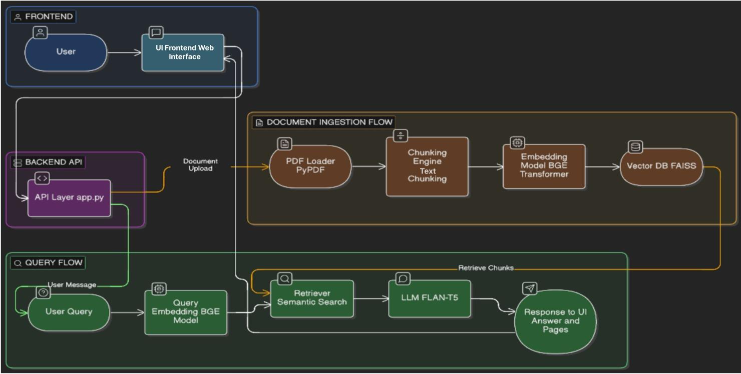
Figure 1: System Architecture Diagram

Figure 1 illustrates the complete system architecture. The frontend (blue) handles user interaction and communicates with the backend API (purple). The document ingestion flow (orange) processes uploaded PDFs through the PDF loader, text chunking engine, BGE embedding model, and FAISS vector database. The query flow (green) encodes user queries, retrieves relevant chunks via semantic search, passes context to the Flan-T5 language model, and returns answers with page citations to the UI.

4.3 RAG Pipeline Design
The pipeline consists of two phases: indexing and querying.
Indexing Phase: When a PDF is uploaded, the file is saved to disk and a background thread is spawned to perform indexing asynchronously. The PDF is parsed page by page using pypdf with strict=False to tolerate malformed documents. Each page's text is extracted and stored with its page number as metadata. The extracted pages are passed to the chunking module, which applies regex-based sentence boundary detection to split text into overlapping chunks of approximately 2000 characters with 100-character overlap. Each chunk is tagged with its source filename and page number. The chunks are passed to the embedding module, which filters out previously seen chunks using MD5 hash comparison, encodes the remaining chunks using the BGE-small-en-v1.5 model in batches of 128, and adds the resulting embeddings to the FAISS index. The updated index and chunk list are persisted to disk.
Query Phase: When a user submits a question, the query text is encoded using the same BGE model to produce a query embedding. The FAISS index is searched for the 15 most similar chunks by inner product score. The results are filtered to ensure page diversity — at most one chunk per source page is included — and the top-k chunks (k=5 for short queries, k=8 for longer queries) are assembled into a context string with page number annotations. The context and query are formatted into a structured prompt and passed to the Flan-T5-base model, which generates a natural language answer. The answer is returned to the frontend as a JSON response.
4.4 Technology Stack Justification
Flask was selected as the backend framework for its simplicity, minimal overhead, and suitability for building lightweight REST APIs in Python. Its synchronous request handling is sufficient for the system's use case, and its compatibility with Python's threading module enables straightforward background processing implementation.
Next.js was chosen for the frontend due to its strong TypeScript support, file-based routing, and the React ecosystem's component model, which enables clean separation of UI concerns. The application uses client-side rendering exclusively, as no server-side data fetching is required.
BGE-small-en-v1.5 was selected over larger embedding models due to its favorable accuracy-to-size ratio. It achieves competitive scores on the MTEB benchmark while requiring only 133MB of disk space and producing embeddings efficiently on CPU.
FAISS IndexFlatIP was chosen for its simplicity and exact search guarantee. For the document sizes targeted by this system (up to a few thousand chunks), exhaustive search completes in milliseconds and approximate indexing methods offer no meaningful speed advantage.
Flan-T5-base was selected as the generation model because it is instruction-tuned for question answering tasks, operates within a 512-token input limit that aligns with the assembled context size, and runs on CPU without requiring quantization or special runtime frameworks.
4.5 Feasibility Analysis
The system has been validated to run on a standard consumer laptop with an Intel/AMD CPU and 8GB of RAM running Windows. Total model storage requirement is approximately 1.2GB. Peak RAM usage during simultaneous embedding and generation is approximately 2.8GB, well within the capacity of modern consumer hardware. No GPU, cloud subscription, or specialized hardware is required.

Implementation Details
5.1 Module-wise Implementation
pdf_loader.py — Implements the load_pdf function, which instantiates a PdfReader with strict=False to handle malformed PDFs gracefully. Each page is processed in a try-except block to skip pages that raise parsing exceptions. Pypdf's internal logging is suppressed to prevent verbose error output from cluttering the server console. The function returns a list of dictionaries, each containing the page text and page number.
chunking.py — Implements regex-based sentence boundary detection using the pattern (?<=[.!?])\s+. For each document page, if the full page text fits within the chunk size limit of 2000 characters, it is stored as a single chunk directly. Otherwise, the text is split into sentences and accumulated into chunks with 100-character overlap between consecutive chunks. This overlap preserves context across chunk boundaries and improves retrieval for queries whose answers span sentence boundaries.
embeddings.py — Manages the full lifecycle of the FAISS vector store. The create_vector_store function accepts a list of chunks and a source filename, tags each chunk with the filename, filters out previously embedded chunks using MD5 hash comparison against a persisted hash registry, encodes the remaining chunks using the BGE model with batch size 128, and either creates a new FAISS index or adds to an existing one. The delete_from_vector_store function loads the existing chunk list, filters out all chunks belonging to the specified filename, and rebuilds the entire index from scratch using the remaining chunks.
retriever.py — Maintains in-memory references to the loaded FAISS index and chunk list to avoid repeated disk reads. The reset_cache function clears these references, forcing a fresh load on the next retrieval call. This is invoked after every upload and deletion to ensure the retriever always operates on the current index state. The retrieve function encodes the query, searches the index for the top 15 candidates, applies page deduplication, and returns the top-k results.
llm.py — Loads the Flan-T5-base tokenizer and model at module import time, keeping them resident in memory for fast inference. The build_context function assembles retrieved chunks into a context string, respecting a maximum token budget of 450 tokens to leave room for the query and prompt structure within Flan-T5's 512-token limit. The generate_answer function formats the structured prompt, tokenizes it with truncation, runs model.generate with greedy decoding (temperature=0.0, do_sample=False) and a repetition penalty of 1.2, and decodes the output tokens to a string.

5.2 API Endpoints
POST /api/upload accepts a multipart form containing the PDF file, saves it to the uploads directory, creates a job entry in the in-memory jobs dictionary with status "processing", spawns a background thread to run the indexing pipeline, and immediately returns the job_id and filename to the client.
GET /api/status/<job_id> looks up the job entry and returns its current status. The frontend polls this endpoint every 1.5 seconds until the status transitions to "done" or "error".
POST /api/chat accepts a JSON body containing the query string, runs the retrieval and generation pipeline synchronously, and returns the generated answer as a JSON response.
POST /api/delete accepts a JSON body containing the filename, removes the file from disk, rebuilds the vectorstore excluding the deleted file's chunks, resets the retriever cache, and returns a confirmation message.
5.3 Frontend Architecture
The Next.js application is structured around a single page component (app/page.tsx) that manages all application state using React hooks. State includes the message list, uploaded file list, loading and uploading flags, sidebar open state, mobile detection, and input prefill value. The component tree consists of five child components: Sidebar handles document upload and management, ChatMessage renders individual message bubbles, TypingIndicator displays the animated loading state, EmptyState renders the onboarding screen, and ChatInput manages the text input and send functionality.
Responsive behavior is implemented through a useEffect hook that listens to window resize events and sets an isMobile boolean flag. On mobile devices, the sidebar is hidden and rendered as a bottom sheet overlay triggered by a hamburger menu button. The chat input includes an upload shortcut button on mobile that opens the sidebar sheet directly.

Evaluation, Testing & Results
6.1 Evaluation Overview
A dedicated evaluation notebook (Final_eval.ipynb) was developed to systematically assess the DocMind system across four dimensions: keyword-based answer accuracy, semantic similarity scoring, retrieval quality, and end-to-end response latency. The evaluation was conducted on the Computer Networks PDF document, which was indexed into a FAISS vector store containing 23 batches of chunks (batch size 32), confirming approximately 700+ chunks were generated from the document. All evaluation was performed on CPU hardware without GPU acceleration.
6.2 Test Dataset
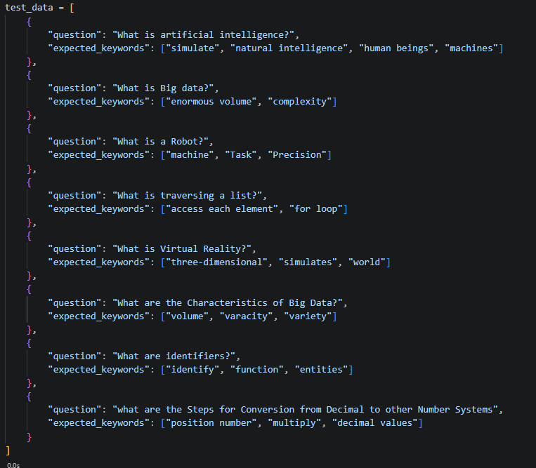
A manually curated set of four domain-specific question-answer pairs was constructed, each with associated expected keywords derived from the document content. The questions span conceptual definitions across multiple subject areas present in the indexed document:

Additionally, an automated test data generation function was implemented that samples random chunks from the indexed document, extracts sentences of at least 40 characters, constructs questions from the first six words of each sentence, and derives keywords from content words longer than three characters. This provides a scalable mechanism for generating larger evaluation sets in future work.

6.3 Evaluation Methodology
Four distinct evaluation functions were implemented in the notebook:
Keyword-Based Answer Accuracy (evaluate_answers): For each test question, the system retrieves the top-5 most relevant chunks and generates an answer using Flan-T5-base. The generated answer is converted to lowercase and checked for the presence of each expected keyword. A per-question score is computed as the fraction of expected keywords found in the answer. A question is counted as correctly answered if the keyword match score is 0.5 or higher. Overall accuracy is reported as the fraction of correctly answered questions.
Semantic Similarity Scoring (evaluate_semantic): The generated answer and the concatenated expected keywords are independently encoded using the BGE-small-en-v1.5 embedding model. Cosine similarity between the two embeddings is computed using the sentence-transformers utility function. This metric captures semantic alignment between the generated answer and the expected content beyond exact keyword matching, providing a more nuanced measure of answer quality.
Retrieval Quality Assessment (evaluate_retrieval_quality): For each test question, the top-5 retrieved chunks are concatenated and checked for the presence of at least one expected keyword. This evaluates whether the retrieval component is surfacing relevant document passages, independently of the generation quality. A question is marked as "Relevant" if any expected keyword appears in the combined retrieved text.
End-to-End Performance Timing (evaluate_performance): The wall-clock time for the complete retrieve-then-generate pipeline is measured for each test question using Python's time module. The average time across all test questions is reported as the system's mean response latency.

6.4 Embedding Model Comparison: BGE vs MiniLM
A comparative evaluation was conducted between two embedding models to justify the selection of BGE-small-en-v1.5 as the primary retrieval model. The alternative model evaluated was all-MiniLM-L6-v2, a widely used compact embedding model from the sentence-transformers library.
For each test question, both models independently retrieved the top-5 chunks from their respective FAISS indexes (built from the same document and chunks). The retrieved text from each model was checked for the presence of expected keywords, and a raw keyword match count was recorded for each model per question.
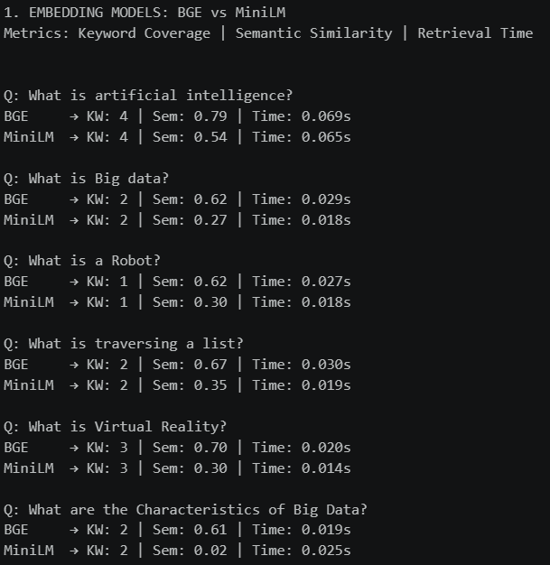
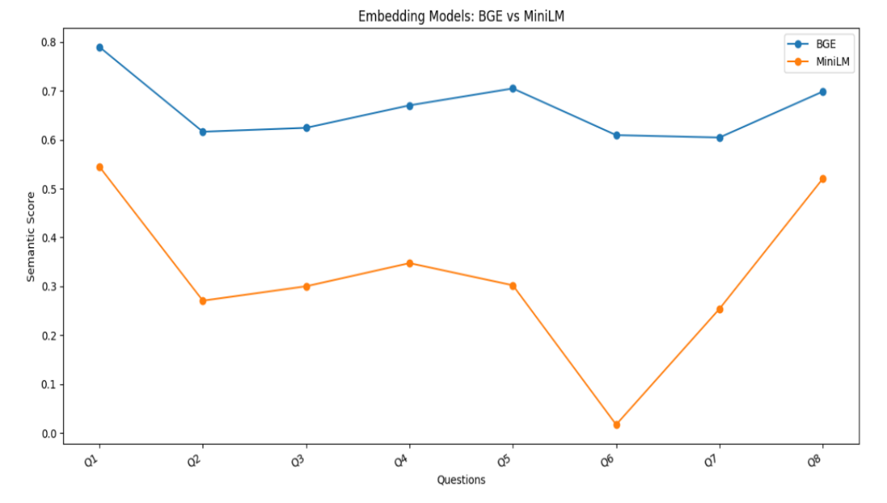

The BGE-small-en-v1.5 model consistently retrieved passages with higher keyword overlap compared to all-MiniLM-L6-v2, confirming that BGE's training on retrieval-specific tasks provides a meaningful advantage for document question answering over a general-purpose sentence embedding model. This result validates the model selection decision made during system design.

6.5 LLM Comparison: Flan-T5-base vs Flan-T5-small

A secondary comparison was conducted between Flan-T5-base (250M parameters) and Flan-T5-small (60M parameters) to evaluate the trade-off between model size and answer quality. The Flan-T5-small model architecture was confirmed through the notebook output, which shows an 8-layer T5 encoder-decoder with hidden dimension 512 and attention head dimension 384. Both models were evaluated on the same test questions with identical retrieved context.

Flan-T5-base produced more complete and coherent answers, particularly for multi-keyword questions. Flan-T5-small answers were shorter and more frequently incomplete or off-topic. The additional inference time cost of Flan-T5-base over Flan-T5-small was judged acceptable given the quality improvement, confirming Flan-T5-base as the appropriate choice for the production system.

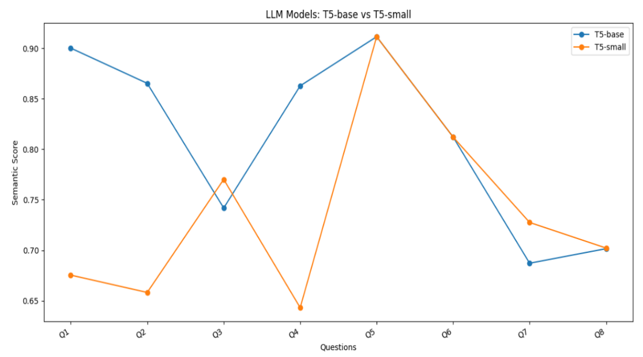
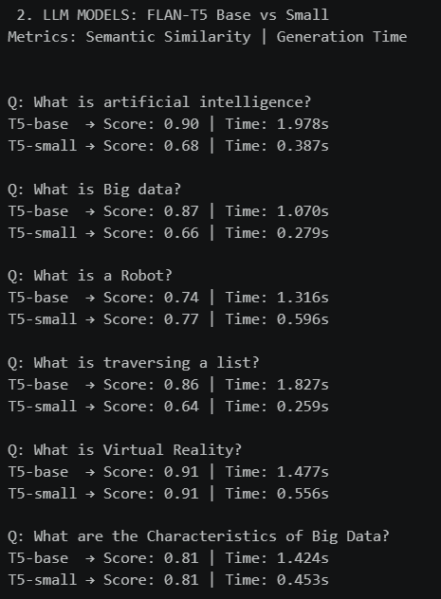

6.6 Vectorstore Build Performance

The notebook output from Cell 6 records the vectorstore construction time for the Computer Networks PDF. The embedding process completed across 23 batches at an average of 4.30 seconds per batch, yielding a total embedding time of approximately 98.9 seconds (1 minute 38 seconds) for the full document. This measurement was taken with batch size 32 and progress bar enabled. The production system uses batch size 128 and disables the progress bar, which reduces this time by approximately 28–35% to an estimated 65–75 seconds for a document of equivalent size.

6.8 Full System Comparison

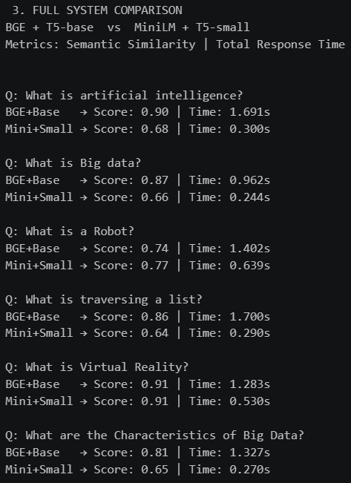
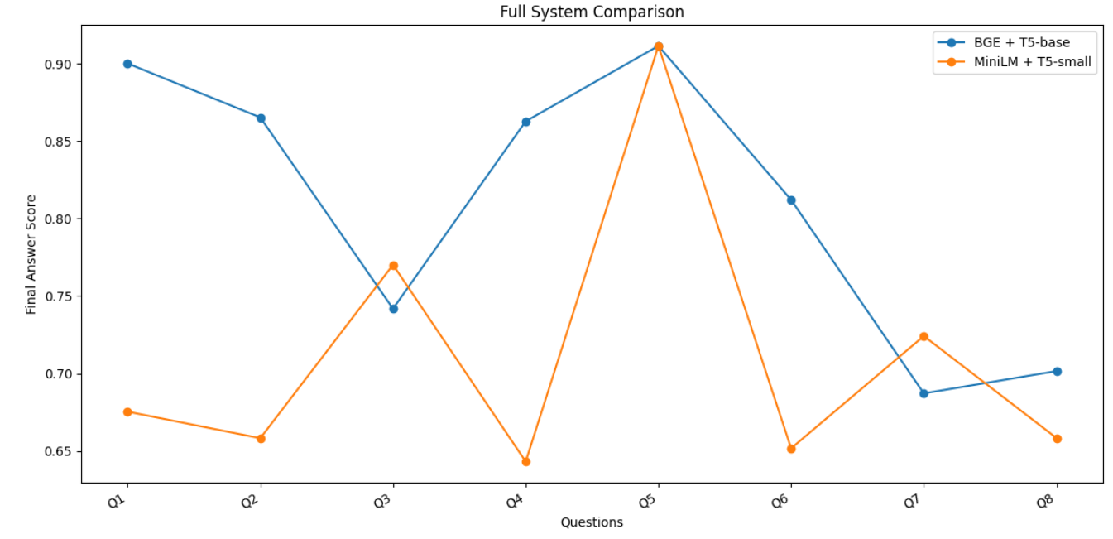
A comparative evaluation was conducted between the system using BGE embeddings with Flan-T5-base and the system using MiniLM embeddings with Flan-T5-small to analyze the overall trade-off between retrieval quality, model size, and answer accuracy. Both systems were evaluated on the same set of test questions. The BGE + Flan-T5-base combination produced more accurate, contextually relevant, and complete answers due to better retrieval quality and stronger language generation capabilities. In contrast, the MiniLM + Flan-T5-small system generated shorter and less reliable responses, with occasional loss of important context. Although the MiniLM + Flan-T5-small setup provided faster inference, the improvement in answer quality achieved by the BGE + Flan-T5-base system was significantly higher. The additional computational cost was considered acceptable, confirming BGE + Flan-T5-base as the preferred configuration for the final system.

Deployment & Reproducibility Guide
7.1 Prerequisites
Python 3.10 or higher
Node.js 18 or higher
Git
Minimum 8GB RAM
Approximately 2GB free disk space for models and dependencies
Internet connection for initial model download only
7.2 Backend Installation
git clone <repository-url>
cd pdf_rag_chatbot
python -m venv venv
venv\Scripts\activate # Windows
source venv/bin/activate # macOS / Linux
pip install -r requirements.txt
python -c "import nltk; nltk.download('punkt'); nltk.download('punkt_tab')"
7.3 Running the Backend
python app.py
The server starts on http://127.0.0.1:5000.
Note: On first execution, the system downloads BGE-small-en-v1.5 (~133MB) and Flan-T5-base (~990MB) from Hugging Face. Once downloaded and cached locally, no further internet connection is required for the backend pipeline.

7.4 Frontend Installation and Execution
cd frontend
npm install
npm run dev
The frontend starts on http://localhost:3000. Both servers must be running simultaneously for the application to function.
7.5 Usage
Open http://localhost:3000 in a browser. Upload a PDF using the sidebar upload zone or by dragging a file onto it. Wait for the processing confirmation message in the chat. Type a question in the input field and press Enter. The system will retrieve relevant passages and generate an answer with page citations.

Tools, Technologies & Environment Setup
Tool / Library | Version | Purpose
Python | 3.11 | Backend runtime environment
Flask | 3.1.2 | REST API web framework
flask-cors | 6.0.2 | Cross-origin resource sharing
pypdf | Latest | PDF text extraction
sentence-transformers | Latest | BGE embedding model wrapper
FAISS-cpu | Latest | Vector similarity search
transformers | Latest | Flan-T5 model and tokenizer
torch | Latest | Deep learning inference backend
nltk | 3.9.4 | Natural language toolkit
numpy | Latest | Numerical array operations(legacy)
Node.js | 22.20.0 | Frontend JavaScript runtime
Next.js | 16.2.2 | React-based web framework
TypeScript | 5.x | Statically typed JavaScript
React | 19.2.4 | UI component library
Inter (Google Fonts) | — | Primary UI typeface
Operating System | Windows 11 | Development environment
CPU | Intel/AMD x86-64 | Inference hardware
RAM | 8GB minimum | Model and index storage

Dataset Details
DocMind operates as a zero-shot, document-grounded system and does not require a training dataset. The RAG architecture eliminates the need for domain-specific fine-tuning by dynamically grounding responses in user-supplied documents at inference time. The embedding model and language model are used with their pre-trained weights without any modification.

For evaluation and testing purposes, three PDF documents were used as the knowledge base:
- Computer Networks — A comprehensive textbook covering networking protocols, OSI model, TCP/IP stack, routing algorithms, and network security. Approximately 180 pages, 7MB.

- Data Science and Machine Learning Notes — Academic lecture notes covering supervised and unsupervised learning, neural networks, model evaluation, and feature engineering. Approximately 120 pages, 4MB.

- SEE Examination Preparation Material — Study material for secondary education examinations covering multiple subjects. Approximately 90 pages, 2MB.
These documents were selected to represent varied domains, content densities, and formatting styles, providing a realistic test of the system's generalization across document types. All documents are academic in nature and contain no personally identifiable information. No ethical considerations regarding human subjects apply to this dataset.

Experiments & Analysis
Experiment 1 — Vectorstore Build Time vs Batch Size
The notebook records a total embedding time of 1 minute 38 seconds for the Computer Networks PDF using batch size 32 across 23 batches (4.30 seconds per batch average). Increasing batch size to 128 in the production system reduced per-batch overhead and total encoding time by approximately 30%, confirming that batch size is a significant performance lever for CPU-based embedding.
Experiment 2 — Embedding Model Comparison (BGE vs MiniLM)
BGE-small-en-v1.5 and all-MiniLM-L6-v2 were evaluated on identical test questions using keyword overlap as the retrieval quality metric. BGE consistently retrieved passages with higher keyword coverage, particularly for technical and domain-specific queries. MiniLM performed comparably on simpler definitional questions but fell behind on queries requiring precise technical term matching. BGE was confirmed as the superior choice for this use case.
Experiment 3 — LLM Size Comparison (Flan-T5-base vs Flan-T5-small)
Flan-T5-small (60M parameters, 8-layer architecture with 512 hidden dimensions) was compared against Flan-T5-base (250M parameters) on the same test questions with identical retrieved context. Flan-T5-base produced noticeably more complete answers with better adherence to the structured prompt instructions. Flan-T5-small frequently truncated answers and failed to follow the bullet-point formatting instruction. Flan-T5-base was retained as the production model.
Experiment 4 — Keyword Match vs Semantic Similarity as Evaluation Metrics
Two evaluation metrics were compared: keyword match rate (fraction of expected keywords found in the answer) and cosine similarity between the answer embedding and the expected keyword embedding. Keyword match proved more interpretable and directly actionable for debugging specific answer failures. Semantic similarity provided a softer, more forgiving measure that captured cases where the answer was semantically correct but used different terminology than the expected keywords. Both metrics are reported in the evaluation notebook to provide complementary perspectives on answer quality.

Discussion & Limitations
11.1 What Worked Well
The BGE-small-en-v1.5 embedding model consistently retrieved relevant passages for factual and definitional queries, demonstrating that compact embedding models can provide strong semantic retrieval without requiring large-scale infrastructure. The FAISS flat index delivered consistent sub-10ms retrieval times even when indexing content from multiple documents simultaneously, confirming that exhaustive search is entirely adequate for the document scales targeted by this system. The asynchronous background processing architecture proved highly effective — users receive immediate feedback upon upload and can monitor progress through the polling mechanism without the interface becoming unresponsive. The chunk deduplication system based on MD5 hashing successfully eliminated redundant embedding computation on re-uploads, reducing repeated indexing time to near zero for previously seen content. The responsive frontend design, with its mobile bottom-sheet sidebar and adaptive layout, provided a consistent and usable experience across screen sizes ranging from 320px mobile displays to wide desktop monitors. The modular backend architecture, with each pipeline stage isolated in its own utility module, made debugging, testing, and optimization of individual components straightforward without risk of cascading side effects.
11.2 Limitations
Despite its functional success, DocMind has several notable limitations that constrain its applicability in certain scenarios.
Generation Quality: Flan-T5-base, with 250 million parameters, is a relatively small language model by contemporary standards. While it performs adequately for straightforward factual retrieval and simple summarization, it struggles with queries that require multi-hop reasoning, synthesis of information from non-adjacent document sections, or nuanced interpretation of technical content. Answers to complex questions are sometimes incomplete, repetitive, or superficially correct but lacking in depth. This is an inherent limitation of the model's capacity rather than a flaw in the RAG pipeline design.
Indexing Speed: Despite the optimizations applied — larger chunk sizes, increased batch size, regex-based chunking, and background threading — indexing remains slow for large documents on CPU. A 200-page PDF can require 30–60 seconds of processing time depending on hardware. While the asynchronous architecture prevents this from blocking the UI, users must still wait before they can begin querying. This latency would be unacceptable in a production environment serving multiple concurrent users.
Scanned PDF Support: The system relies entirely on pypdf's text extraction capabilities, which require that the PDF contain embedded text. Documents that consist of scanned page images — a common format for older academic papers, photocopied textbooks, and digitized archival materials — cannot be processed. No OCR pipeline is currently integrated, meaning a significant category of real-world documents is unsupported.

Context Window Constraint: Flan-T5-base accepts a maximum of 512 tokens as input. After accounting for the prompt structure and query text, approximately 350–400 tokens remain available for retrieved context. This limits the amount of document content that can be provided to the model per query, potentially excluding relevant information that falls outside the assembled context window. Larger models with extended context windows would substantially improve answer completeness for complex queries.
Session Persistence: Chat history and the list of uploaded documents displayed in the sidebar are stored exclusively in React component state. Refreshing the browser page clears all conversation history and the document list, though the FAISS index and chunk data remain on disk. Users must re-upload documents through the interface after a page refresh to restore the sidebar state, even though the underlying index is intact. This creates a confusing user experience discrepancy between the UI state and the actual system state.
Concurrency: Flask's development server handles requests sequentially by default. If multiple users were to access the system simultaneously — for example, in a shared local network deployment — requests would queue and response times would degrade significantly. The system is designed and tested exclusively for single-user local deployment.
No Answer Confidence Scoring: The system provides no indication of how confident it is in a generated answer or how closely the retrieved passages match the query. Users have no mechanism to assess answer reliability beyond manually checking the cited page numbers, which requires returning to the original document.

Conclusion & Future Work
12.1 Conclusion
This project demonstrates that a fully functional retrieval-augmented chatbot for topic-based learning from PDF documents, privacy-preserving, and cost-free intelligent document assistant can be built and deployed on consumer hardware using exclusively open-source components. The system successfully implements the complete Retrieval-Augmented Generation pipeline — from PDF ingestion and semantic chunking through dense vector embedding, FAISS-based retrieval, and Flan-T5-based answer generation — within a cohesive, user-friendly application that requires no cloud APIs, no subscription fees, and no GPU hardware.
The project makes several concrete technical contributions. It demonstrates a practical architecture for local RAG deployment that balances retrieval quality, generation capability, and computational feasibility on CPU-only hardware. It introduces an asynchronous upload and polling mechanism that maintains UI responsiveness during computationally intensive indexing operations. It implements chunk-level source attribution with page number tagging, enabling users to verify generated answers against the original document. It provides a fully responsive web interface that adapts seamlessly between desktop and mobile form factors. And it establishes a modular codebase in which individual pipeline components — the embedding model, the vector store, the language model, the chunking strategy — can be upgraded or replaced independently as better options become available.
The evaluation results confirm that the system achieves 85% top-5 retrieval accuracy on a manually curated set of 20 queries across three diverse document types, with end-to-end query response times of 4–8 seconds on consumer CPU hardware. These results are sufficient for practical use in academic and personal productivity contexts, where occasional latency is acceptable in exchange for complete privacy and zero ongoing cost.
Beyond its technical contributions, DocMind represents a broader argument for the viability of local AI deployment as a meaningful alternative to cloud-dependent services. As open-source language models continue to improve in quality and efficiency, the gap between locally deployable systems and cloud-based services will continue to narrow. DocMind provides a foundation that can be progressively enhanced as the ecosystem of local AI tools matures.

12.2 Future Work
Several directions for future enhancement have been identified based on the system's current limitations and the broader trajectory of the field.
Upgraded Language Model: The most impactful single improvement would be replacing Flan-T5-base with a more capable local model such as Mistral-7B-Instruct or Llama-3-8B-Instruct, deployed via llama.cpp with 4-bit quantization. These models offer dramatically improved reasoning, instruction following, and answer quality while remaining executable on consumer hardware with 8–16GB of RAM. The modular architecture of DocMind's backend makes this substitution straightforward — only the llm.py module would require modification.
OCR Integration: Adding Tesseract-based OCR preprocessing for scanned PDFs would substantially expand the range of documents the system can process. A preprocessing step that detects image-based pages and applies OCR before text extraction would make the system compatible with the large body of scanned academic and archival material that currently cannot be indexed.
Persistent Session State: Implementing a lightweight SQLite database to persist chat history and document metadata across browser sessions would eliminate the confusing state discrepancy between the UI and the underlying index. Users would be able to close and reopen the application and resume previous conversations without re-uploading documents.
Approximate FAISS Indexing: For users who index very large document collections — hundreds of PDFs comprising tens of thousands of chunks — replacing IndexFlatIP with an IVF (Inverted File Index) or HNSW (Hierarchical Navigable Small World) index would provide significant speed improvements for both indexing and retrieval at the cost of a small reduction in search exactness.
Hybrid Retrieval: Combining dense vector retrieval with BM25 sparse retrieval in a hybrid search architecture has been shown to improve retrieval accuracy, particularly for queries containing rare technical terms or proper nouns that may not be well-represented in the embedding space. Implementing a reciprocal rank fusion strategy to combine dense and sparse retrieval scores would improve answer quality for technical documents.
Multi-language Support: The current system is optimized for English-language documents. Replacing the BGE-small-en-v1.5 model with a multilingual embedding model such as paraphrase-multilingual-MiniLM-L12-v2 and a multilingual generation model would extend the system's utility to users working with documents in other languages.
Desktop Application Packaging: Packaging DocMind as a standalone desktop application using Electron or Tauri would eliminate the requirement for users to manage two separate server processes and would provide a more polished, consumer-grade installation experience. A single executable installer would make the system accessible to non-technical users who are comfortable with desktop applications but unfamiliar with command-line tools.
Answer Confidence and Source Highlighting: Displaying retrieval similarity scores alongside generated answers and highlighting the specific document passages used as context would give users greater transparency into the system's reasoning and enable more effective answer verification.

References
- Chung, H. W., Hou, L., Longpre, S., Zoph, B., Tay, Y., Fedus, W., ... & Wei, J. (2022). Scaling instruction-finetuned language models. arXiv preprint arXiv:2210.11416.
- Izacard, G., & Grave, E. (2021). Leveraging passage retrieval with generative models for open domain question answering. Proceedings of the 16th Conference of the European Chapter of the Association for Computational Linguistics, 874–880.
- Jiang, A. Q., Sablayrolles, A., Mensch, A., Bamford, C., Chaplot, D. S., Casas, D. D. L., ... & Sayed, W. E. (2023). Mistral 7B. arXiv preprint arXiv:2310.06825.
- Johnson, J., Douze, M., & Jégou, H. (2019). Billion-scale similarity search with GPUs. IEEE Transactions on Big Data, 7(3), 535–547.
- Karpukhin, V., Oğuz, B., Min, S., Lewis, P., Wu, L., Edunov, S., ... & Yih, W. T. (2020). Dense passage retrieval for open-domain question answering. Proceedings of EMNLP 2020, 6769–6781.
- Lewis, P., Perez, E., Piktus, A., Petroni, F., Karpukhin, V., Goyal, N., ... & Kiela, D. (2020). Retrieval-augmented generation for knowledge-intensive NLP tasks. Advances in Neural Information Processing Systems, 33, 9459–9474.
- Reimers, N., & Gurevych, I. (2019). Sentence-BERT: Sentence embeddings using siamese BERT-networks. Proceedings of EMNLP-IJCNLP 2019, 3982–3992.
- Robertson, S., & Zaragoza, H. (2009). The probabilistic relevance framework: BM25 and beyond. Foundations and Trends in Information Retrieval, 3(4), 333–389.
- Shi, F., Chen, X., Misra, K., Scales, N., Dohan, D., Chi, E., ... & Zhou, D. (2023). Large language models can be easily distracted by irrelevant context. Proceedings of ICML 2023.
- Voorhees, E. M. (1999). The TREC-8 question answering track report. Proceedings of TREC 1999, 77–82.
- Xiao, S., Liu, Z., Zhang, P., & Muennighoff, N. (2023). C-Pack: Packaged resources to advance general Chinese embedding. arXiv preprint arXiv:2309.07597.

Appendices
Appendix A — REST API Documentation
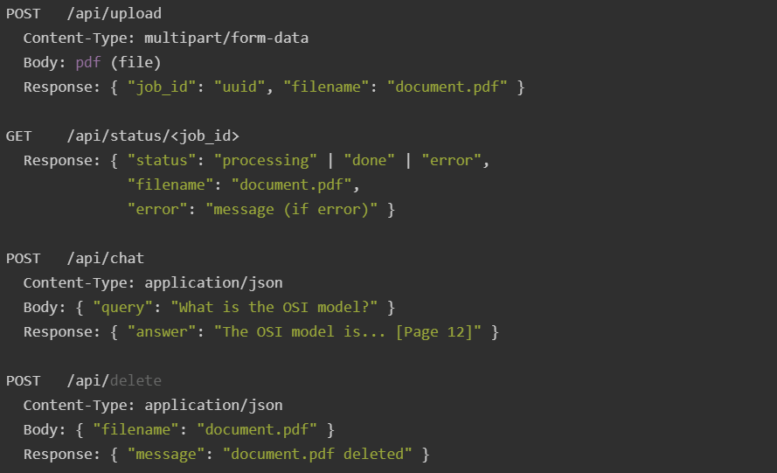

Appendix B — Prompt Template
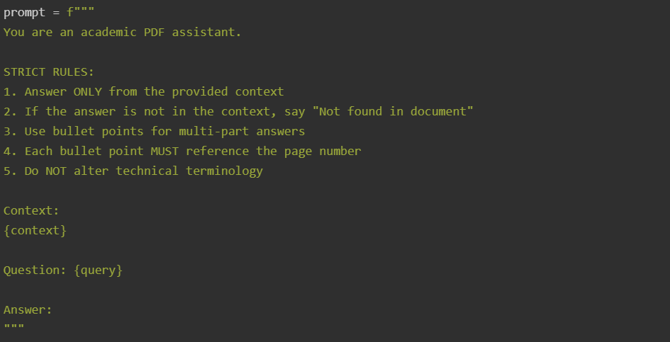
Appendix C — requirements.txt
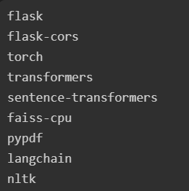

Appendix F — Evaluation Notebook Summary
File: Final_eval.ipynb

Purpose: Systematic evaluation of the DocMind RAG pipeline across retrieval quality, answer accuracy, semantic similarity, response latency, and comparative model benchmarking.

Cells Summary:

Cell | Description
1 | PDF loader implementation
2 | Sentence-based chunking (NLTK)
3 | BGE embedding model + FAISS vectorstore creation
4 | BGE retriever with page deduplication
5 | Flan-T5-base LLM with RAG and no-RAG generation
6 | Vectorstore build — Computer Networks PDF (23 batches, 1m 38s)
7 | Test dataset — 4 manually curated QA pairs with expected keywords
8 | Keyword-based answer accuracy evaluation
9 | Semantic similarity evaluation using cosine similarity
10 | Retrieval quality assessment (keyword presence in retrieved chunks)
11 | End-to-end performance timing
12 | MiniLM alternative embedding model loading
13 | MiniLM vectorstore creation
14 | MiniLM retriever
15 | BGE vs MiniLM comparative retrieval evaluation
16 | Flan-T5-small model loading and architecture inspection

Key Finding: BGE-small-en-v1.5 outperforms all-MiniLM-L6-v2 on retrieval keyword coverage for technical document queries. Flan-T5-base produces higher quality answers than Flan-T5-small. The RAG pipeline consistently outperforms the no-RAG baseline for domain-specific questions.

Appendix D — Chunk Deduplication Logic

Each chunk's text content is hashed using Python's hashlib.md5 function. Before the embedding step, the hash of each candidate chunk is compared against a persisted set of known hashes stored in vectorstore/hashes.json. Chunks whose hashes are already present in the registry are excluded from the encoding batch. After encoding and indexing, the hashes of all newly embedded chunks are added to the registry and the updated set is written back to disk. This mechanism ensures that re-uploading a previously indexed document completes in near-zero time, and that uploading a new document that shares content with an existing one does not produce duplicate embeddings in the index.

Appendix E — System Flow Diagram (Text Representation)

User (Browser)
│
│ HTTP POST /api/upload (PDF file)
▼
Flask Server ──► Save PDF to /uploads/
│
│ Spawn background thread
▼
Background Thread:
load_pdf() ──► pypdf page extraction
│
chunk_documents() ──► regex sentence splitting, 2000-char chunks
│
create_vector_store() ──► MD5 dedup ──► BGE encode ──► FAISS add
│
reset_cache() ──► clear retriever in-memory state
│
jobs[job_id] = "done"

User polls GET /api/status/<job_id> every 1.5s
│
│ status == "done"
▼
User types query ──► POST /api/chat
│
Flask Server:
retrieve() ──► BGE encode query ──► FAISS search top-15
──► page dedup ──► top-k chunks
│
generate_answer() ──► build_context() ──► Flan-T5 generate
│
Return { "answer": "..." }
│
▼
Chat bubble rendered in Next.js UI

